SUPREME COURT OF THE STATE OF NEW YORK COUNTY OF NASSAU  ------------------------------------------ | X
In the Matter of the Application of  FELIX PROCACCI,  Petitioner,  -against-  TOWN OF HEMPSTEAD  Respondent.  ------------------------------------------ | :  :  :  :  :  :  :  :  :  :  :  :  :  X | Date Purchased :  Index No. ________  PETITION

TO THE SUPREME COURT OF THE STATE OF NEW YORK, COUNTY OF NASSAU:
The petition of Felix Procacci respectfully shows to this Court as follows:

- Petitioner Felix Procacci resides at 1165 Barnes St, Franklin Square, New York 11010, located in the County of Nassau.
- Petitioner is appearing pro se on the matter presented in this petition and is fully familiar with the facts and circumstances surrounding them.
- Respondent Town of Hempstead (hereinafter referred to as “the Town”) is a municipal corporation organized and existing under the laws of the State of New York with its principal place of business located at One Washington Street, Hempstead, New York, County of Nassau.
- This proceeding is brought pursuant to Article 78 of the Civil Procedure Law and Rules in the nature of mandamus to compel Respondents to comply with all applicable provisions of New York State General Business Law, New York State Zoning Law, Hempstead Town Zoning Law, the United States Constitution, and the Constitution of the State of New York.
Nature of the Proceeding
- This proceeding is brought to compel Respondents to rescind the provisions of the Town's Building Zone Ordinance, in § 336G(3) of Article XXXIII, that mandates gasoline station operators provide compressed air at no charge in cases of an emergency. Hereinafter these provisions shall be referred to as the Town's “Emergency Free Air Law”. A copy of said law is attached hereto as Exhibit 1.
- The Town's “Emergency Free Air Law” preempts New York State's General Business Law (GBL) 396-X which allows gasoline service stations to charge for compressed air. A copy of said law is attached hereto as Exhibit 2.
- The Town's “Emergency Free Air Law” also preempts New York State's zoning law Article 16 § 261, Grant of Power, which does not have any provision to allow a Town to regulate the operation of a business through the use of Zoning Law. A copy of said Grant of Power is attached hereto as Exhibit 3.
- The Town's “Emergency Free Air Law” also preempts the Town's Zoning law regarding Gasoline Service Stations, Article XXXIII § 330, Legislative Intent, which does not have any provision to allow the Town to regulate the operation of a business through the use of Zoning Law. A copy of said Legislative Intent is attached hereto as Exhibit 4.

The Town Enacted the “Emergency Free Air Law”
to Settle Litigation

- The Town's “Emergency Free Air Law” was enacted as a compromise to settle the litigation of the Town's Law that prohibited payment for compressed air under all circumstances. Hereinafter this law shall be referred to as the Town's “Free Air Law”.
- This fact was made evident during the exchange between Hempstead Town Councilman Blakeman and the Plaintiff's lawyer (Erica Dubno) in the “Free Air Law” litigation during the August 7, 2018 hearing on the “Emergency Free Air Law” (see video at https://youtu.be/O2WaQrBwpJQ?t=4144).
- In the video, Councilman Blakeman says “I thought if we pass this law that would settle the litigation”. Erica Dubno responds, “That is correct”.
- In crafting the “Emergency Free Air Law” as part of a legal settlement, the Town's concern was not on land usage, as required by State and Town Zoning laws, but instead on cutting a deal to end the “Free Air Law” litigation.
- On October 25, 2018, all parties in the “Free Air Law” litigation signed a Stipulation of Discontinuance. A copy of said Stipulation is attached hereto as Exhibit 5.
Prelude to the Settlement of “Free Air Law” Litigation
- On January 2, 2018, Supreme Court Judge Karen V. Murphy issued an injunction of the Town's “Free Air Law”. A copy of said injunction is attached hereto as Exhibit 6.
- The injunction was issued because the court decided the Plaintiffs were likely to prevail on the merits of their third cause of action as pled in their second amended complaint which alleged that the Town's “Free Air Law” preempted New York State GBL 396-X. The Plaintiff's third cause of action is attached hereto as Exhibit 7.
- Said injunction, in pertinent part, states the following :
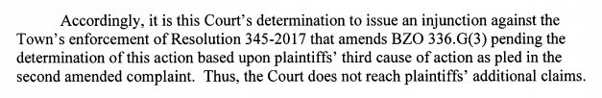
- The Plaintiff's third cause of action (in the “Free Air Law” litigation), in pertinent part, provides :
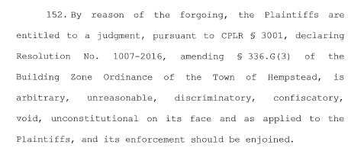
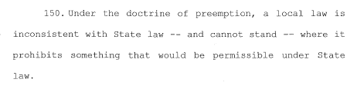
- It follows that the “Emergency Free Air Law” also preempts New York State Law since the “Emergency Free Air Law” still mandates how gasoline stations should provide compressed air, which is governed by New York State GBL 396-X.

“Emergency Free Air Law” Also Violates Zoning Case Law
- The “Emergency Free Air Law” does not regulate the use and regulation of land and therefore it is an invalid zoning regulation.
- All the following references to Rathkopf's The Law of Zoning and Planning are attached hereto as Exhibit 8.
- “The zoning power, as limited by the statutory grant, must operate in relation to the use of land and not for the accomplishment of purposes extraneous to that relation. If safety factors or health measures require zoning controls, they must involve safety and health characteristics which relate to the land under the regulation.” (ref: 1 Rathkopf's The Law of Zoning and Planning § 2.25, 4th ed.).
- “To be valid, a zoning ordinance, or decision thereunder, must further a legitimate object and utilize a method of achieving it authorized by the state zoning enabling act.” (ref. 1 Rathkopf's The Law of Zoning § 2.25, 4th ed.).
- “Courts recognize that the zoning power is merely one category of the more general police power and, as such, is one specifically concerned and limited to regulation of the use of land within a jurisdiction.” (ref: 1 Rathkopf's The Law of Zoning and Planning § 2.25, 4th ed.).
- “A zoning ordinance or decision thereunder will be held ultra vires when it promotes an objective or utilized a method of regulation beyond the purview of the state enabling act.” (ref: 1 Rathkopf's The Law of Zoning and Planning § 2.25, 4th ed.).
- A zoning restriction “imposed for considerations or purposes not embodied in an enabling act will be held as invalid, not as exceeding the scope of the police power per se, but as an ultra vires act beyond the statutory authority delegated.” (see: 9 Rathkopf's The Law of Zoning and Planning § 2.15 (4th ed.).
- By preempting New York General Business Law 396-X, New York Town Zoning law, and Hempstead Town Zoning law, the Town of Hempstead is violating the protections provided by the Fourteenth Amendment to the United States Constitution and Article I §11 of the New York State Constitution which provides equal protection under the law. The Fourteenth Amendment to the United States Constitution and Article I §11 of the New York State Constitution are attached hereto as Exhibit 9.

Petitioner Has Standing
- An unaggrieved Citizen-Taxpayer has standing to Constitutionally challenge a local law (see St. John's Law Review, Issue 1, Volume 39, December 1964, Number 1). Referenced portion is attached hereto as Exhibit 10.
- The Petitioner is an unaggrieved citizen-taxpayer in this matter but has standing. (see: Policeman's Benevolent Ass'n v. Board of Trustees, 21 App. Div. 2d 693, 250 N.Y.S.2d 523, 2d Dep't 1964).
- “It is well settled that where there is no disputed question of material fact but only an issue of law, the relief here requested may be awarded in a mandamus proceeding” (see: Matter of Ahern v. Bd. of Supervisors, 17 Misc. 2d 164, N.Y. Misc. 1959).
- The Petitioner has standing because the Town, in enacting a law that conflicts with New York State Town Zoning Law, has failed to perform a duty enjoined to it by law.
- The Petitioner has standing because the Town, in enacting a law that conflicts with Hempstead Town Zoning Law, has failed to perform a duty enjoined to it by law.

Petitioner Has Standing - continued
- The Petitioner has standing because the Town, in enacting a law that conflicts with New York State GBL 396 X, has failed to perform a duty enjoined to it by law.
- The Petitioner has standing because the Town, in passing a law that violates the Constitutional right of its citizens to have equal protection under the law, has failed to perform a duty enjoined to it by law.
- Petitioner has no other remedy at law.

WHEREFORE, Petitioner FELIX PROCACCI respectfully requests an order compelling Respondent TOWN OF HEMPSTEAD, to rescind the “Emergency Free Air Law”, Town's Building Zone Ordinance, § 336G(3) of Article XXXIII, based on the overwhelming evidence this Petition provides, that it violates New York GBL 396-X, as stated in the injunction by the Nassau Supreme Court, it violates New York State and Town zoning laws, and zoning case law which show that zoning regulations that do not relate to land usage are invalid.
In addition, the Petitioner requests that said Respondent pay all costs of this legal action because the Respondent acted in bad faith when it enacted the “Emergency Free Air Law” as a compromise in settling litigation of the “Free Air Law”.

DATED: Nassau County, New York
November _____, 2018

Respectfully submitted,

_______________________
Felix Procacci
Pro Se
1165 Barnes Street
Franklin Square, New York 11010
(516) 233-1562
EXHIBIT 1
Town of Hempstead Building Zone Ordinance
Article XXXIII § 336G(3), “Emergency Free Air Law”
Page 1 of 2
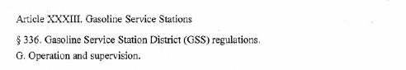
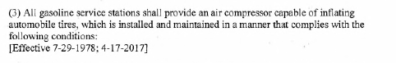

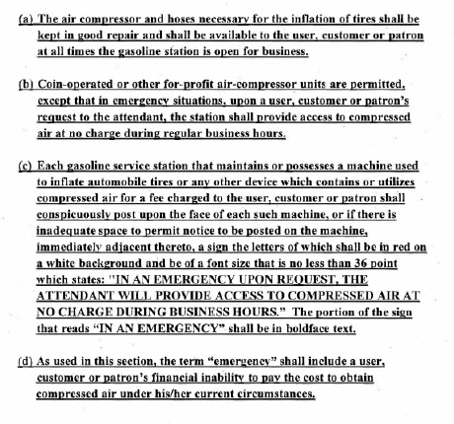

EXHIBIT 1 - continued
Town of Hempstead Building Zone Ordinance
Article XXXIII § 336G(3), “Emergency Free Air Law”
Page 2 of 2

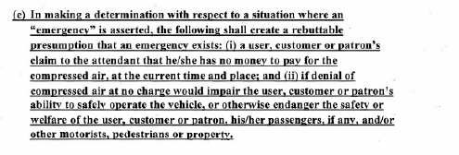
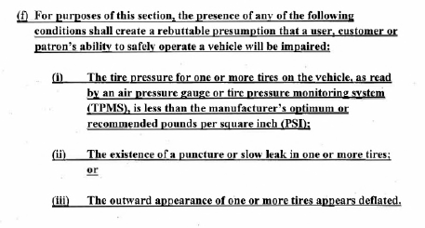
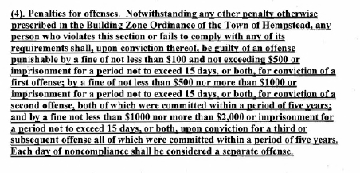
EXHIBIT 2
New York General Business Law
Section 396-X
Gasoline Stations; Air Pumps Required

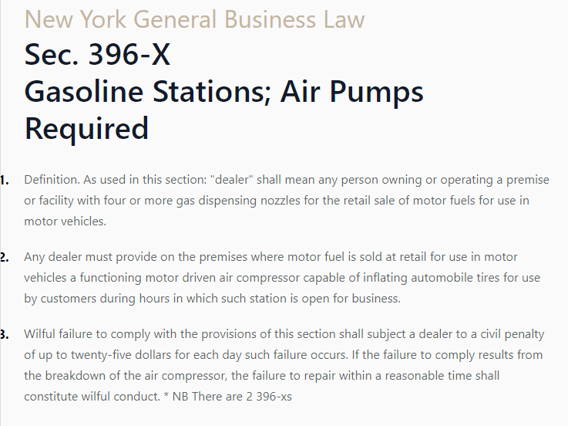

EXHIBIT 3
New York Consolidated Laws, Town Law - TWN §261
Grant of Power

New York Consolidated Laws, Town Law - TWN § 261. Grant of power; appropriations for certain expenses incurred under this article
For the purpose of promoting the health, safety, morals, or the general welfare of the community, the town board is hereby empowered by local law or ordinance to regulate and restrict the height, number of stories and size of buildings and other structures, the percentage of lot that may be occupied, the size of yards, courts, and other open spaces, the density of population, and the location and use of buildings, structures and land for trade, industry, residence or other purposes; provided that such regulations shall apply to and affect only such part of a town as is outside the limits of any incorporated village or city; provided further, that all charges and expenses incurred under this article for zoning and planning shall be a charge upon the taxable property of that part of the town outside of any incorporated village or city. The town board is hereby authorized and empowered to make such appropriation as it may see fit for such charges and expenses, provided however, that such appropriation shall be the estimated charges and expenses less fees, if any, collected, and provided, that the amount so appropriated shall be assessed, levied and collected from the property outside of any incorporated village or city. Such regulations may provide that a board of appeals may determine and vary their application in harmony with their general purpose and intent, and in accordance with general or specific rules therein contained.

EXHIBIT 4
Town of Hempstead, Building Zone Ordinance (BZO)
Article XXXIII Gasoline Service Stations
§ 330 Legislative Intent

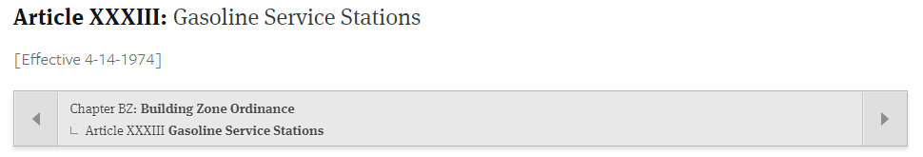
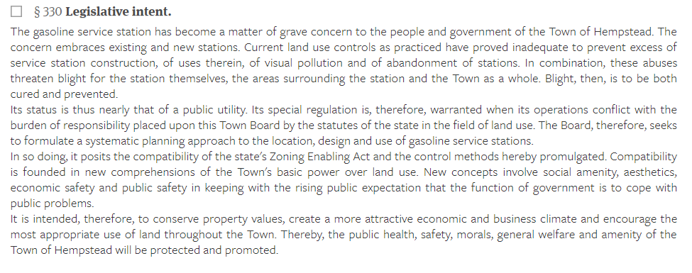

EXHIBIT 5
Stipulation of Discontinuance of “Free Air Law”
Page 1 of 2
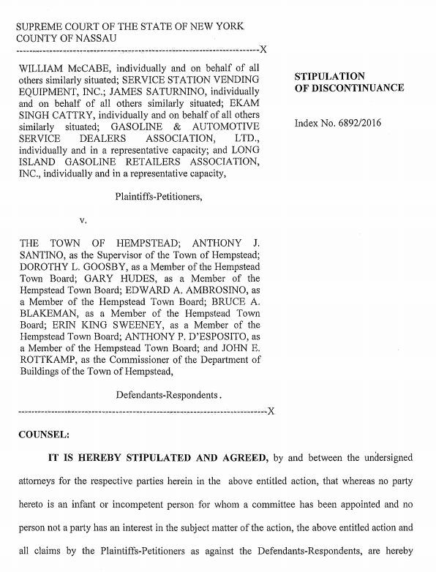
EXHIBIT 5 - continued
Stipulation of Discontinuance of “Free Air Law”
Page 2 of 2
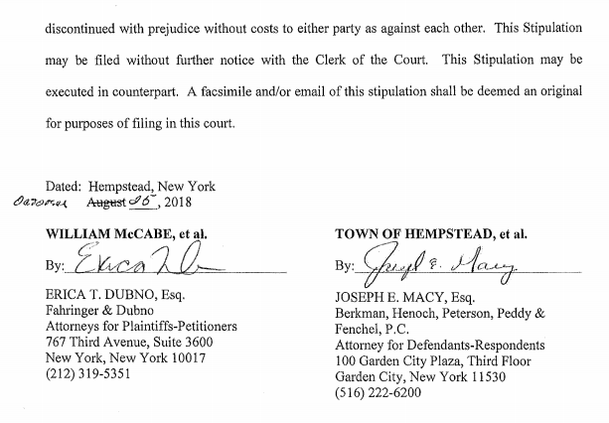
EXHIBIT 6
Court Ordered Injunction of Town's “Free Air Law”
Page 1 of 5
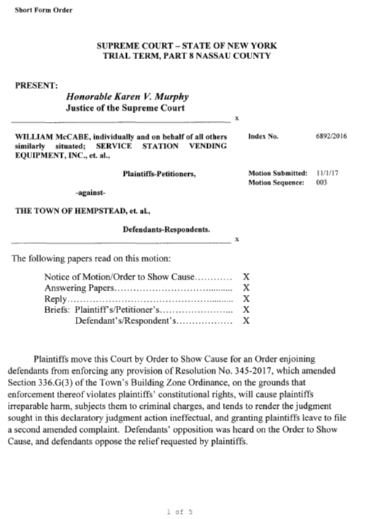
EXHIBIT 6 - continued
Court Ordered Injunction of Town's “Free Air Law”
Page 2 of 5
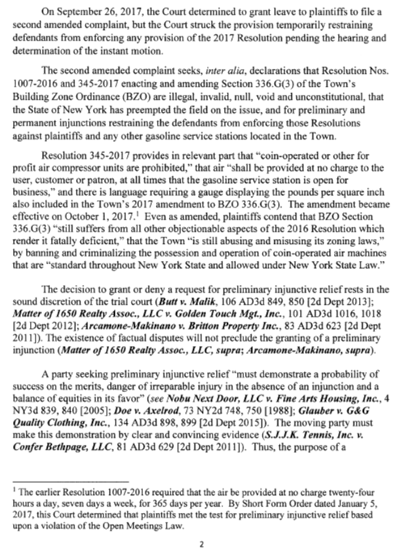

EXHIBIT 6 – continued
Court Ordered Injunction of Town's “Free Air Law”
Page 3 of 5
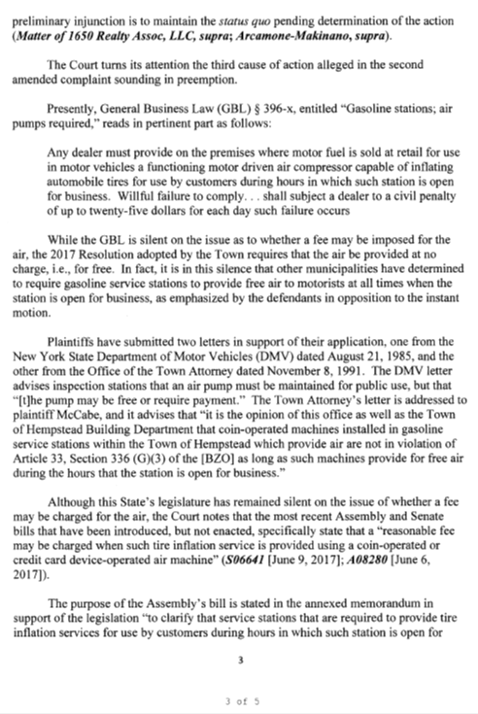

EXHIBIT 6 - continued
Court Ordered Injunction of Town's “Free Air Law”
Page 4 of 5
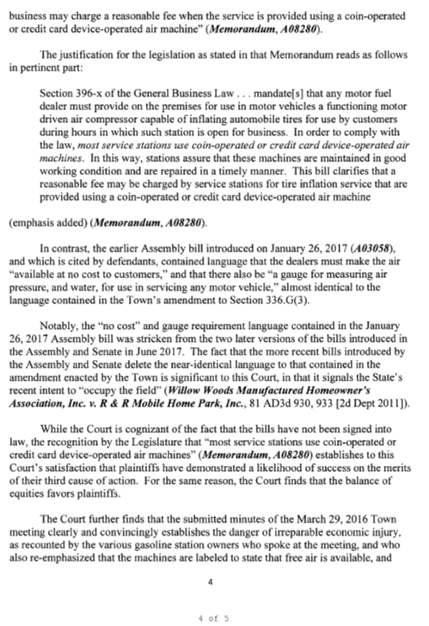

EXHIBIT 6 - continued
Court Ordered Injunction of Town's “Free Air Law”
Page 5 of 5

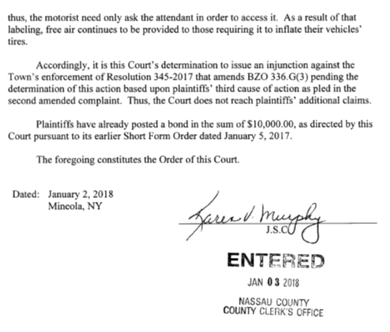
EXHIBIT 7
Plaintiff's Third Cause of Action from
the “Free Air Law” Litigation
Page 1 of 2
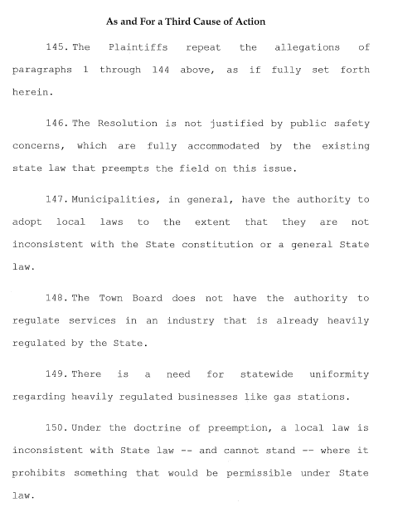
EXHIBIT 7 - continued
Plaintiff's Third Cause of Action from
the “Free Air Law” Litigation
Page 2 of 2
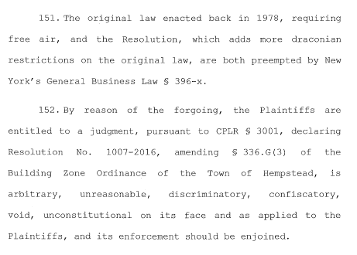
EXHIBIT 8
References to Rathkopf's
The Law of Zoning and Planning § 2:15 (4th ed.)
Page 1 of 4
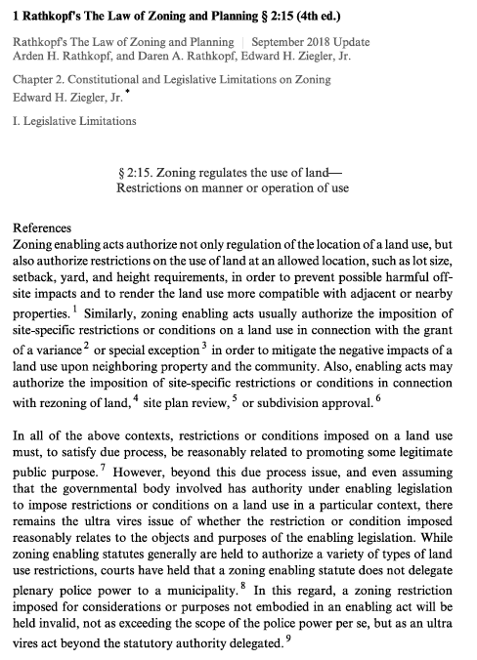
EXHIBIT 8
References to Rathkopf's
The Law of Zoning and Planning § 2:15 (4th ed.)
Page 2 of 4
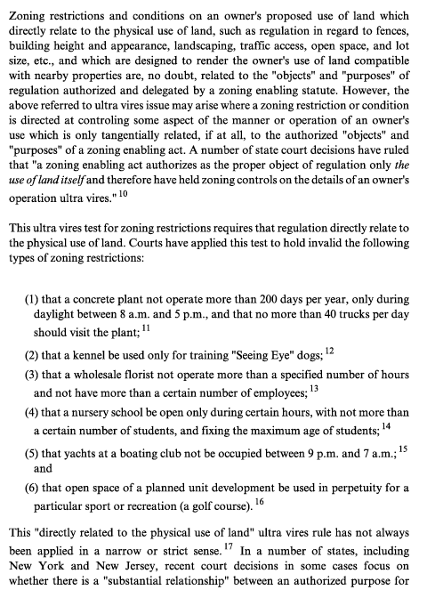

EXHIBIT 8 - continued
References to Rathkopf's
The Law of Zoning and Planning § 2:25 (4th ed.)
Page 3 of 4
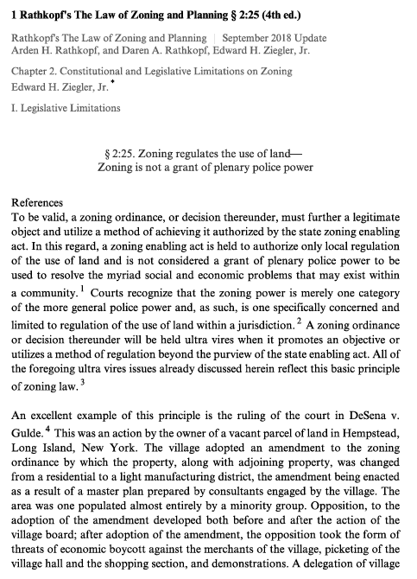

EXHIBIT 8 - continued
References to Rathkopf's
The Law of Zoning and Planning § 2:25 (4th ed.)
Page 4 of 4
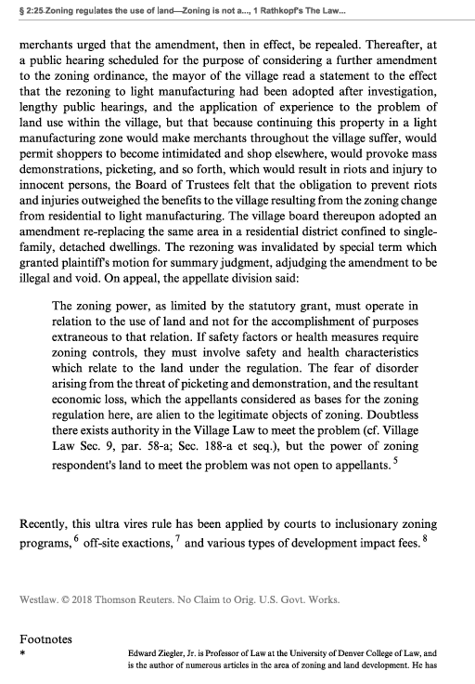

EXHIBIT 9
Fourteenth Amendment – Section 1
of the United States Constitution

All persons born or naturalized in the United States and subject to the jurisdiction thereof, are citizens of the United States and of the State wherein they reside. No State shall make or enforce any law which shall abridge the privileges or immunities of citizens of the United States; nor shall any State deprive any person of life, liberty, or property, without due process of law; nor deny to any person within its jurisdiction the equal protection of the laws.

Article I §11
of the New York State Constitution

No person shall be denied the equal protection of the laws of this state or any subdivision thereof. No person shall, because of race, color, creed or religion, be subjected to any discrimination in his or her civil rights by any other person or by any firm, corporation, or institution, or by the state or any agency or subdivision of the state.

EXHIBIT 10
St. John's Law Review
Issue 1, Volume 39, December 1964, Number 1
Page 1 of 3
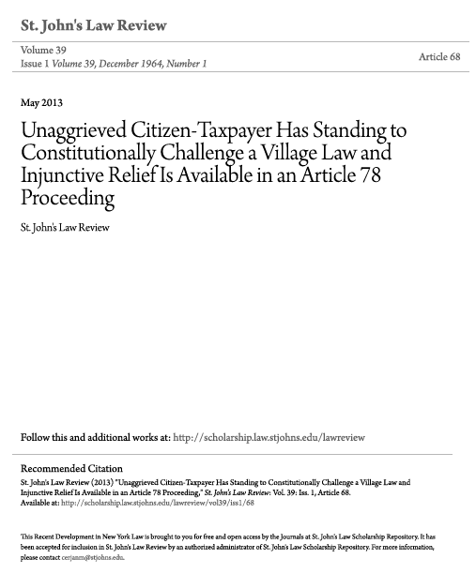
EXHIBIT 10 - continued
St. John's Law Review
Issue 1, Volume 39, December 1964, Number 1
Page 2 of 3
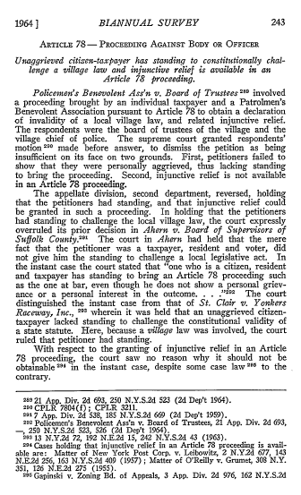
EXHIBIT 10 - continued
St. John's Law Review
Issue 1, Volume 39, December 1964, Number 1
Page 3 of 3

